Create a 3D Moon

**Note: Save often throughout this tutorial!

In Photoshop, navigate to the Moon folder and open up the Moon.jpg file. Click File>>Save As. Change the type to a .PSD and name it Moon.

1. Resize the photo (Image>>Image Size) change the width to 1000 pixels and hit OK.

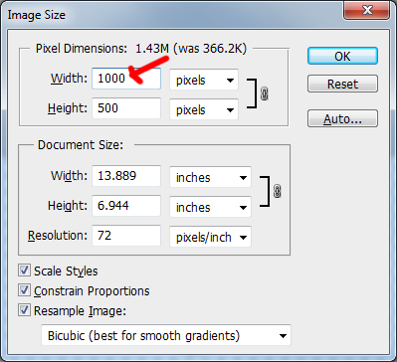

Your moon map should now look pretty small. Use the zoom tool to make it fill more of your work area.

2. Now we will sharpen the image to emphasize the surface details. Use the Smart Sharpen filter (Filter>>Sharpen>>Smart Sharpen) with the following settings:

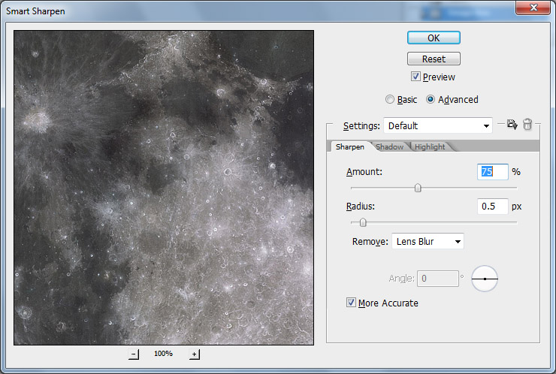

3. Double click the Background layer to unlock it and rename it to "MoonMap".

4. From the menu bar, select: 3D >> New Shape from Layer >> Sphere. This will map the "MoonMap" image layer inside a 3D sphere. We have just created a digital full moon on the screen:

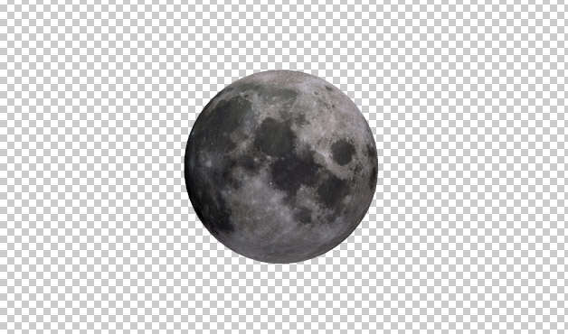

5. Switch to the 3D workspace by selecting Window> > Workspace> > 3D from the pull-down menu.

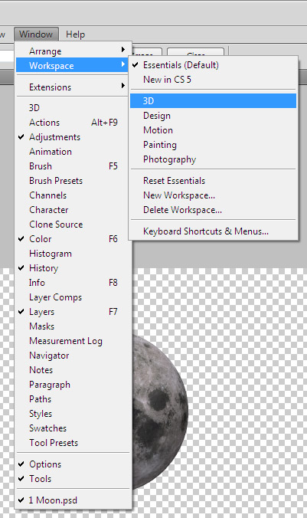

6. In the 3D panel, click on the "Filter by Lights" icon (arrow 1)and then turn off Infinite Light 2, by clicking on the eyeball to the left (arrow 2):

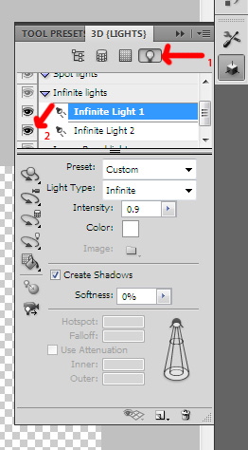

You will now have a dark shadow along the bottom curve of your moon.

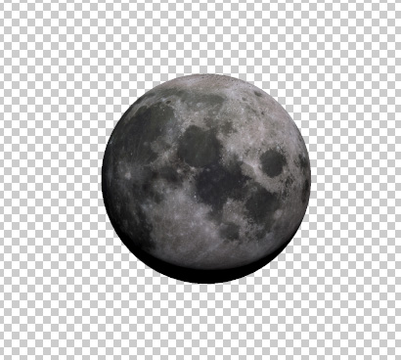

7. Click on Infinite Light 1. Right click on the "Light Rotate" icon and then select the "3D Light Rotate Tool".

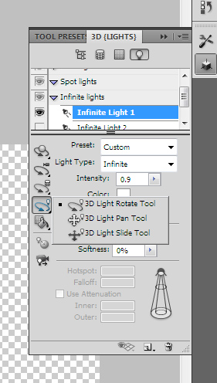

8. Your cursor will change to look like an arrow curved into an oval. Move your cursor so the light so that illuminates the moon comes from the right side (Waxing Gibbous):

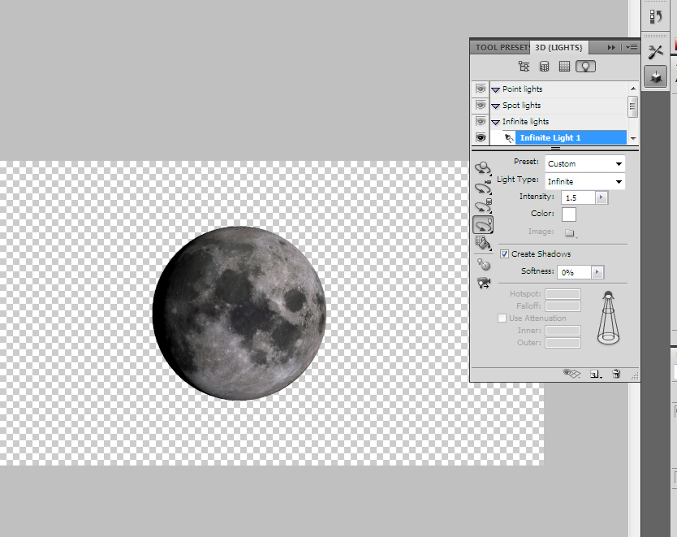

9. Now change the Intensity for the light from 1 to 1.5.

10. When you look at the moon through a telescope what you see is not a flat terrain but a rough surface full of craters and mountain ranges. It doesn't look like the flat moon you are currently looking at on your screen. Let's give some texture to our digital Moon's surface. Go to the Layers panel and double click the "Moon map" texture:

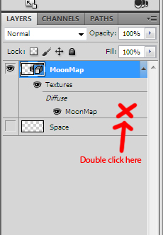

11. This will open a **new document** with the original moon map. (Your moon has NOT disappeared!) Press **Ctrl-A** and then **Ctrl-C** to copy the layer content into the clipboard. If you’ve done it correctly, you will see the “marching ants” around the outside this new document. We will use this copied image to create a texture for the 3D object. **Close the new document.**

12. Go to the 3D panel. Click the "Filter by Whole Scene" icon (arrow 1). Click on "Sphere Material" (arrow 2). Then click the little folder icon to the right of "Bump" (arrow 3) and finally select "New Texture." Then click OK on the window that pops up.

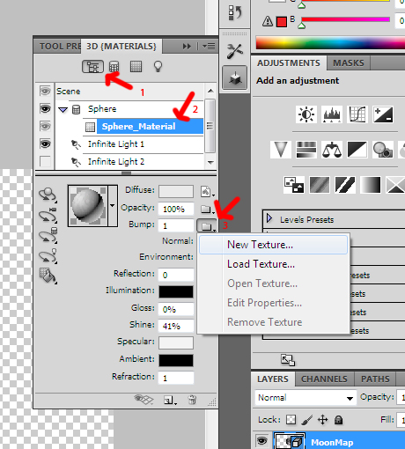

13. The icon to the right of “Bump” will change from a folder. Click on this new icon and select "Open texture".

14. This will open ANOTHER new document. Press Ctrl-V to paste the moon map.

15. Flatten the image by right-clicking one of the layers and selecting “Flatten Image”. Press Ctrl-S to save changes. Close the document.

16. Yay! You can now see the Moon's mountain ranges and crater rims standing out.

17. This file is pretty big, and if we were to render it now, it would probably take an hour or more. Make your moon smaller (Image>>Image Size) change the width to 300 pixels and hit OK.

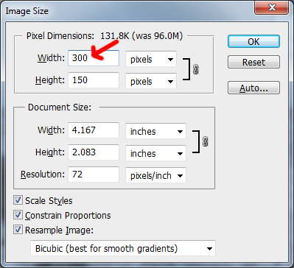

17B. Now we are ready to render the 3D object. On the 3D panel click on "Scene" (arrow 1) and then select "Ray Traced Final" in the "Quality" drop down list (arrow 2):

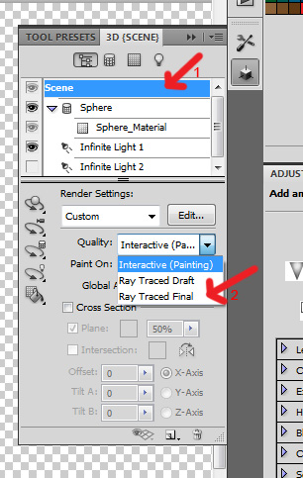

Rendering can take anywhere from a few minutes to half an hour or more, depending on how much RAM you are using. If the rendering is interrupted, you can re-start it by right clicking the MoonMap layer and selecting “Resume Progressive Render”.

18. Now that your moon has rendered, you can make the image larger again (Image>>Image Size) and change the width back to 1000.



19. You have just created a beautiful shot of the moon. You can now move your moon to your Space Scene. Resize it so that it if proportionate to your planets and sun.